Access 'localhost:3000' and below screen appears.

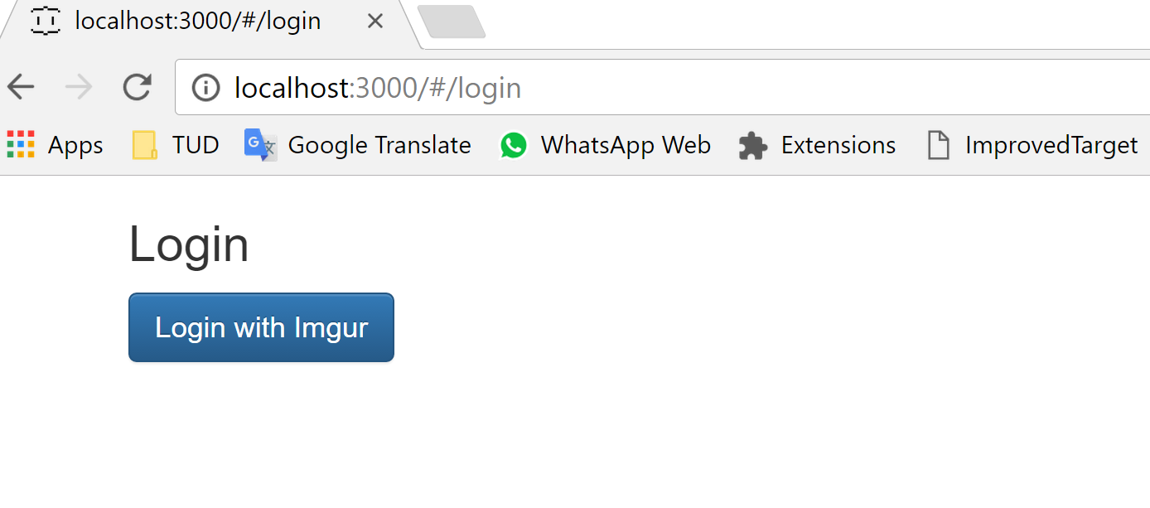
Click on Login and below screen appears. Enter details and click on 'allow'

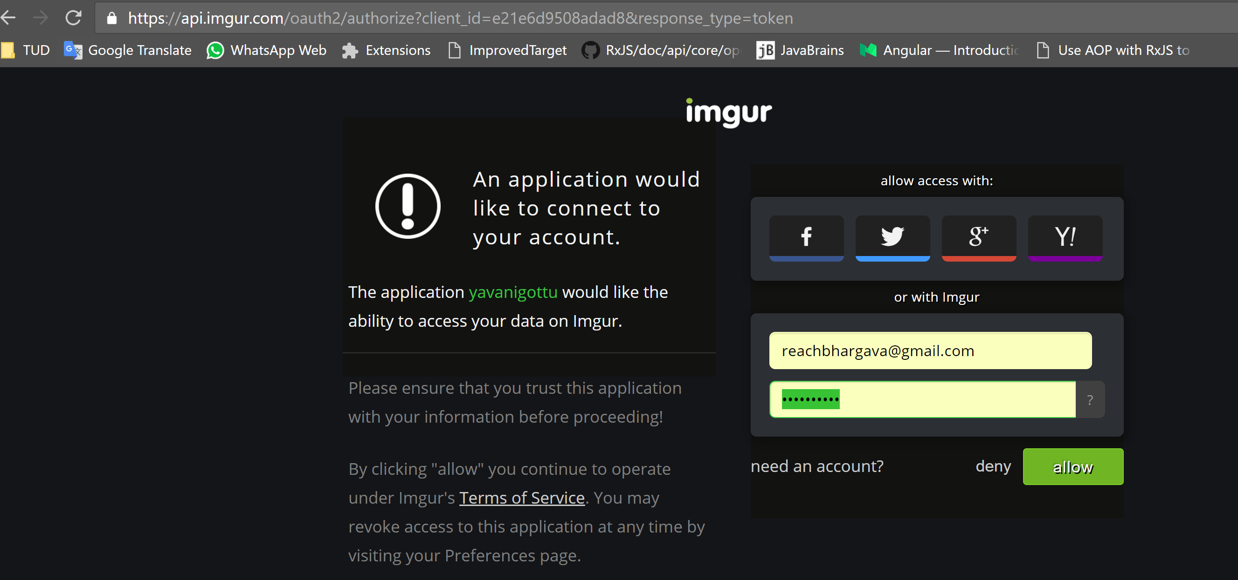
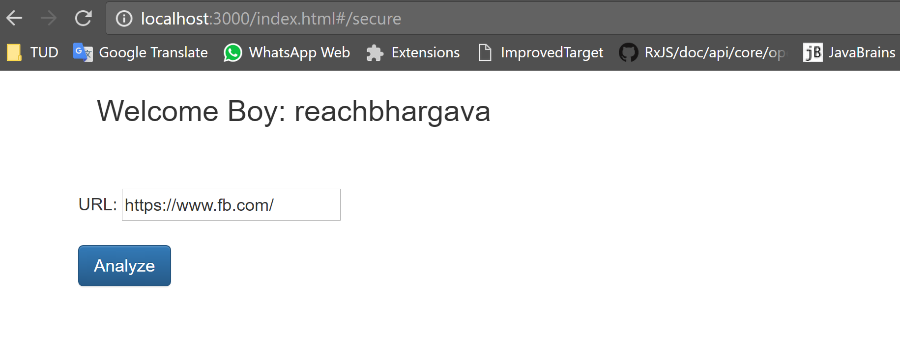
Give the URL and click on 'Analyze'
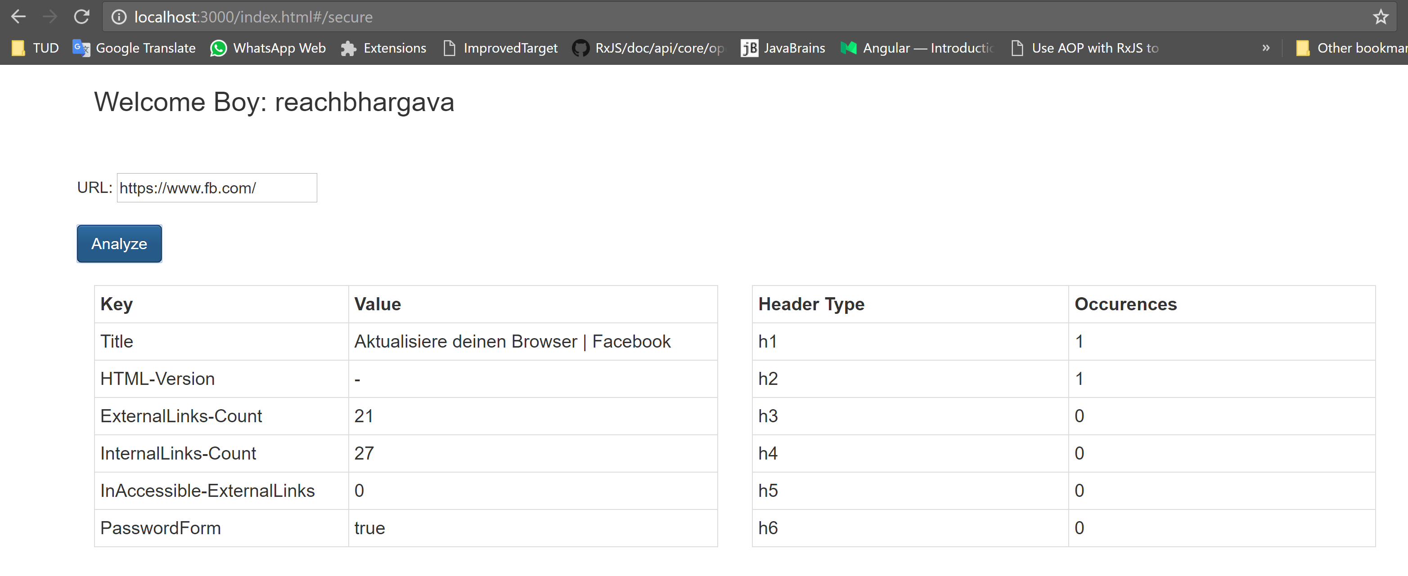
Give a url that does not exist and below page appears

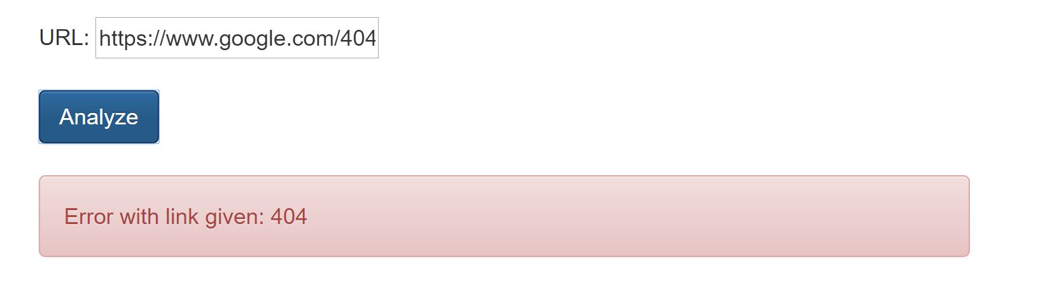

Click some junk url and below appears

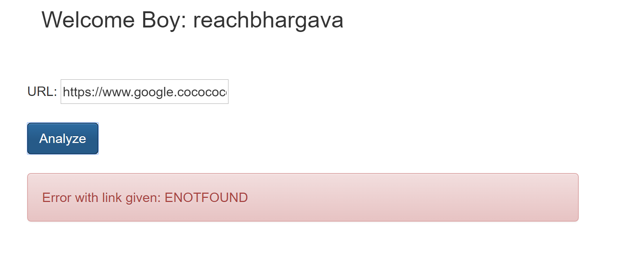

Correct the url and error disappears

